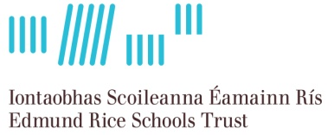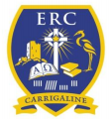

PRINCIPAL
Edmund Rice College
Carrigaline
Co. Cork

The Board of Management of Edmund Rice College, Carrigaline,
invites applications from suitably qualified persons for the post of Principal to take effect from 1st February 2016.

The school is a new co-educational school to be located in
Kilnagleary, Carrigaline and opening on 1st September 2016 under the trusteeship of the Edmund Rice Schools Trust. Projected enrolment
will be 600 at full capacity.

Application forms will be available to download from www.erst.ie or by post from the ERST offices.

Completed printed application forms should be submitted by post to the Edmund Rice Schools Trust, Meadow Vale, Clonkeen Road, Blackrock, Co. Dublin A94 YN6 in an envelope clearly marked ‘ERC Principal’,
no later than 12 noon on Monday 19th October, 2015.

Short listing may apply.
This school is an equal opportunities employer.
Canvassing will disqualify

